1. NeuroBack: Improving CDCL SAT Solving using Graph Neural Networks (2021) - YES
- Uses a GNN to compute static phase predictions before solving.
- CDCL itself remains deterministic.
- No approximation: solver still exact.
- Works on Kissat and improves solve time on benchmarks.
This is one of the cleanest ML → deterministic CDCL integrations.

2. AutoSAT: Automatically Optimize SAT Solver Heuristics via LLMs (2024) - NO
- LLM generates deterministic heuristic code (branching, restart rules).
- Generated heuristic is fixed → solver is fully deterministic.
- Once the model decides the heuristic, CDCL runs exactly as usual.
This is extremely promising because it's deterministic meta-learning, not stochastic local search.

3. Machine Learning for SAT: Restricted-Heuristic Branching (2023) - NO
- ML predicts branching choices only for initial decisions.
- After that, CDCL proceeds deterministically.
- ML inference is deterministic (feed-forward neural nets without randomness).
Perfect deterministic insertion point for your thesis.

4. GNN-Based Branching In CDCL SAT Solving (multiple 2020–2022 papers) - MAYBE
- Replace VSIDS with GNN-based score ranking.
- GNN inference is deterministic.
- CDCL remains sound & complete.
This has direct connections to proof complexity because branching decisions influence the structure of the resolution proof.

5. Predicting Clause Utility for Clause Deletion in CDCL (2021–2023) – YES CLAUSE DETECTION

- Replaces LBD/activity heuristics with deterministic ML predictions.
- Removes clauses deterministically based on learned score.
- CDCL maintains correctness.
Clause deletion is extremely under-explored — fertile ground for thesis work.

6. Learning Restart Strategies for SAT Solvers (2022) - YES
- ML determines a deterministic restart schedule given instance-level features.
- CDCL uses the schedule exactly & deterministically.
- No approximation.
Restarts are a major unsolved mystery in CDCL — very good PhD direction.

7. Meta-learning SAT Solver Configuration (Per-instance deterministic tuning) (2019–2024) - MAYBE
- ML predicts deterministic solver parameter presets (e.g., clause decay, var decay, restart parameters).
- Once selected, solver runs deterministically.
- Still exact SAT solving.
This area is mature enough to build on, but still open for new research.

8. Using ML to Predict Decision Levels / Backjump Lengths (2021–2024) - yes
- Predicts how far to backjump or how to prioritize learned clauses.
- All predictions are deterministic.
- CDCL proof remains valid.
This ties into proof complexity theory.

9. Exact Neural-Symbolic SAT Solving via ML-Guided Heuristics (2020–2022) - YES
- Many works under this umbrella use:
  - deterministic neural networks
  - static scores for variable ordering
  - deterministic tie-breaking
- No approximation at any point.
Good reading for combining neural reasoning + classical CDCL.

🔒 Key Property of All Papers Above
- They do not relax SAT.
- They do not allow probabilistic failure.
- They do not use incomplete stochastic local search.
- They do not produce approximate solutions.
------------------------------------------------------------------------------------------------------------------------
What each candidate gives you (concretely)
(5) Clause deletion — strongest candidate
What you’d actually work on
- Predict which learned clauses are useful
- Replace LBD or activity with a deterministic score
What you’d learn deeply
- Clause database structure
- Conflict frequency
- How clauses help future conflicts
Why this is good
- Local change
- Safe
- Easy to measure
- Easy to justify
This is the best convergence point from your list.

(6) Restarts — very good, but harder
What you’d actually work on
- Learn when to restart
- Fixed restart schedules per instance
What you’d learn
- Search stagnation
- Conflict depth patterns
Risk
- Harder to attribute cause → effect
- Results can be noisy
Good secondary focus, or future extension.

(8) Backjumping — deep but risky
What you’d actually work on
- Predict backjump level or prioritize asserting clauses
Why it’s interesting
- Touches conflict analysis
Why it’s risky
- Easy to break solver
- Hard to debug
Good if you’re confident later, not ideal as first target.

- (5) deeply
- (6) enough to understand
- (9) for language
- (7) lightly
- (8) only if time allows
4. Why clause deletion or restarts (and not branching again)
You already did:
- Phase prediction (1)
- That’s decision-level heuristics
Doing branching again:
- Overlaps heavily
- Harder to beat VSIDS
- Harder to isolate effects
Clause deletion and restarts:
- Are less explored
- Are poorly understood
- Are very powerful
That’s why I’m steering you there.

1.
These papers focus directly on clause database reduction.
Representative / commonly cited ones (you don’t need all, just 1–2):
- “Predicting Clause Utility in SAT Solvers” (2021)
  - ML predicts whether a learned clause will be useful
  - Replaces or augments LBD
  - Deterministic inference
- “Learning to Reduce Learned Clauses in CDCL Solvers” (2022–2023 variants)
  - Uses static or conflict-time features
  - Clause deletion as classification or ranking
What they study
- Which learned clauses help future propagation
- How to control memory growth

2. RESTART STRATEGIES — category (6)
These papers focus only on restarts.
Representative ones:
- “Learning Restart Policies for SAT Solvers” (2022)
  - ML predicts restart timing
  - Uses instance or online features
  - Deterministic schedule once chosen
- “Adaptive Restart Strategies via Machine Learning” (related works)
  - Learns restart aggressiveness
  - Often replaces Luby-style restarts
What they study
- When search is unproductive
- How often to reset the decision stack

3. BACKJUMP PREDICTION — category (8)
These papers focus on conflict analysis behavior.
Representative themes:
- Predict asserting decision level
- Predict how far to backjump
- Prioritize learned clauses that cause deeper jumps
What they study
- Conflict structure
- How information flows backward

- Phase selection — DONE
(5) Clause deletion — review
(6) Restart strategy — review
(8) Backjump prediction — review
Then 1–2 more papers on chosen focus

- 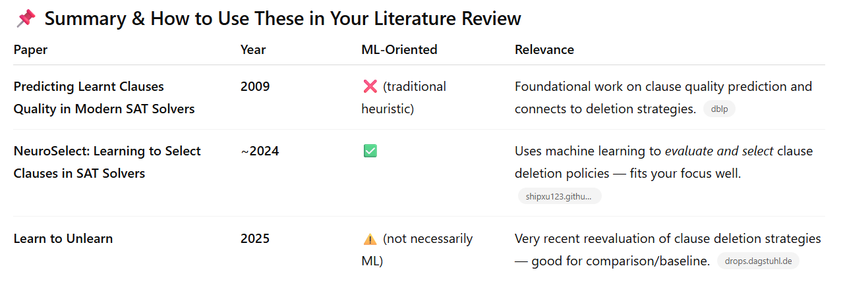

1. Dynamic Metric Adaptation (The "Hybrid" Approach)
Most solvers use a static LBD threshold (e.g., LBD $\leq$ 2 or 3) to protect clauses. However, "Learn to Unlearn" suggests that thresholds should be dynamic.
- Thesis Idea: Develop a Dynamic LBD Adjuster that changes the "glue" threshold based on real-time solver performance (e.g., conflict rate or search depth).
- How it differs: Instead of a fixed rule or an offline ML model like NeuroSelect, you build a "closed-loop" controller inside the solver.
2. The "SAT vs. UNSAT" Duality in Deletion
"Learn to Unlearn" highlights a massive difference: aggressive deletion helps SAT instances but destroys performance on UNSAT.
- Thesis Idea: Create a Divergent Deletion Strategy. Use early search features to predict if an instance is likely SAT or UNSAT, then switch between "aggressive forgetting" and "conservative retention."
- How it differs: Current solvers use the same management policy for both; your thesis would optimize for the specific "flavor" of the problem.
3. Contextual Clause Utility (Beyond LBD)
LBD and activity only look at a clause in isolation or by its age. They don't look at how a clause interacts with others.
- Thesis Idea: "Dependency-Aware Deletion." Use light-weight graph analysis to see if a clause is a "bridge" in the community structure of the formula. If a clause connects two separate variable clusters, it is high-value even if its LBD is high.
- How it differs: It adds a structural "spatial" dimension to the purely "temporal" LBD metric.

Recommended Thesis Roadmap
If you want to focus on clause quality and deletion, here is a suggested step-by-step plan:
- Baseline Selection: Start with a state-of-the-art solver like Kissat (referenced in the 2024/2025 papers).
- Instrumentation: Modify the solver to log not just LBD, but also how often a clause is used as a "reason" for a conflict vs. a "reason" for propagation.
- Hypothesis Testing: Test if "glue" clauses are truly useful throughout the entire search, or if their value drops off after a certain number of restarts.
- Implementation: Build a prototype that uses one of the "Differently" ideas above (e.g., the Divergent Deletion Strategy).
- Evaluation: Compare your results against the standard LBD-based Glucose strategy.
Would you like me to help you draft a formal Thesis Problem Statement based on one of these three specific directions?

++++++++++++++++++++++++++++++++
1. ML-Driven Clause Lifecycle Prediction (Regression/Classification)
Instead of using the static LBD (Literal Block Distance) metric, which is just a "snapshot" of a clause when it's born, you use ML to predict its future utility.
- The Task: Train a Graph Neural Network (GNN) or a LightGBM model to predict: "Will this clause be used in a conflict within the next 10,000 conflicts?"
- The AI Angle: Use features like the clause's connection to the "backdoor" variables or its LBD trend over time.
- Why it's better: It replaces the human-designed LBD rule with a learned "Utility Score."
2. Deep Reinforcement Learning (DRL) for Deletion Policies
NeuroSelect chooses between existing policies. You could go a step further: a DRL agent that manages the solver's memory.
- The Task: The "State" is the current search tree (conflicts, restarts, decision levels). The "Action" is the deletion threshold. The "Reward" is the reduction in decision levels (the "moving to the root" observation from your earlier papers).
- The AI Angle: Frame clause deletion as a Resource Management problem in RL.
- Deterministic Benefit: The agent learns the optimal "rhythm" of when to be aggressive and when to be conservative with memory.
3. Graph-Based "Glue" Identification (GNNs)
The papers mention that "industrial benchmarks" have structure. Standard LBD doesn't actually "see" that structure; it just counts levels.
- The Task: Represent the SAT formula as a Bipartite Graph (variables and clauses as nodes). Use a GNN to identify "bridge" clauses that connect different communities in the graph.
- The AI Angle: Use Unsupervised Representation Learning (like Node2Vec or GraphSAGE) to cluster variables. Clauses that "glue" two different clusters are marked as high-quality.
- Why it's unique: It uses AI to perform "Structural Analysis" that human-coded heuristics currently miss.

Which one fits your interest?
- Idea 1 is great if you like Supervised Learning and feature engineering.
- Idea 2 is the "purest" AI approach, treating the solver like an Environment.
- Idea 3 is best if you are interested in Graph Neural Networks and the "geometry" of logic.
Would you like me to help you define the "State Features" (what the AI actually looks at) for one of these ideas?

2. SAT vs UNSAT Divergent Deletion Strategy
Why this is very strong
This directly exploits a fundamental asymmetry in SAT solving that everyone knows but nobody properly exploits.
- SAT → solution found early → aggressive deletion OK
- UNSAT → proof requires long-term memory → aggressive deletion harmful
This is not cosmetic — it’s structural.
Concrete research questions
- Can early search signals predict SAT vs UNSAT reliably enough?
- How early is “early enough”?
- What is the cost of being wrong?
What you would implement
- Collect early-phase features (first 1–5k conflicts):
  - conflict depth trend
  - restart frequency
  - learnt clause size distribution
- Build:
  - Simple classifier (logistic regression or decision tree)
- Switch deletion strategy:
  - SAT-leaning → aggressive deletion
  - UNSAT-leaning → preserve clauses
Strengths
✅ Very clean hypothesis
✅ No heavy ML infrastructure
✅ Strong empirical payoff
✅ Easy to explain to examiners
Weaknesses
⚠️ Misclassification can hurt performance
⚠️ Needs careful evaluation framing (“expected improvement”)
Verdict
🔥 Top-tier MSc thesis idea
🔥 Also a perfect stepping stone to a PhD

METHODOLOGY
100% deterministic
Thesis problem statement: Current CDCL SAT solvers employ a uniform clause deletion strategy across all problem instances, despite fundamental differences in the role of learned clauses in satisfiable versus unsatisfiable instances. This thesis investigates whether early-stage search dynamics can be used to predict the likely satisfiability status of a SAT instance and based on this prediction, adapt clause deletion policies to better align with the structural requirements of SAT and UNSAT solving.

Input: Early features:
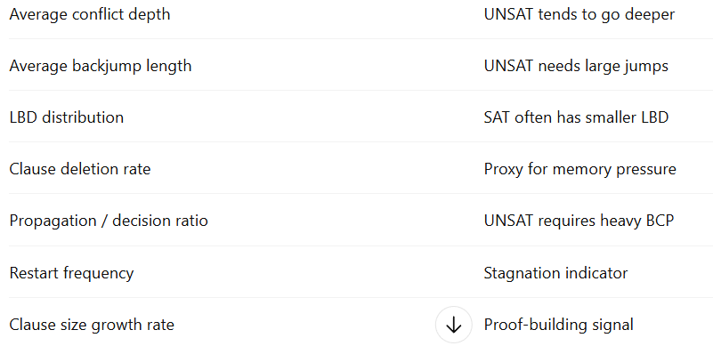
Output:
SAT vs UNSAT probability.
SAT-Leaning Mode
- Lower LBD protection threshold
- Aggressive clause deletion
- Faster forgetting
UNSAT-Leaning Mode
- Higher LBD protection
- Preserve old clauses
- Slower deletion
6. Dataset (Very Important)
Training / Analysis Dataset
- SAT Competition benchmarks:
  - 2016–2021 Main Track
- Use:
  - Known SAT/UNSAT labels
  - Mixed industrial instances

Evaluation Dataset
- SAT Competition 2022 or 2023 Main Track
- Or SAT Race benchmarks
7. Evaluation Metrics
You must evaluate both solver behavior and prediction quality.
Prediction Metrics
- Accuracy
- Precision / Recall
- Confusion matrix
Solver Metrics
- Runtime
- Number of conflicts
- Propagations
- Solved instances under timeout

Why NOT Switch Policies Dynamically?
This is important.
1. Stability
Clause databases are global memory.
Switching policies mid-search can:
- Destroy learned structure
- Create oscillations
- Harm reproducibility

Where the AI Ends (Important)
The ML model:
- Does not control the solver
- Does not score clauses
- Does not choose deletions
- Does not interfere with CDCL
It answers ONE question:
“Which world am I in?”
Everything else is classical SAT.
2️⃣ “SAT-like / UNSAT-like — what exactly is this prediction?”
This is the key conceptual clarification:
You are NOT predicting satisfiability.
You are predicting search behavior resemblance.
What “SAT-like” means (very important)
It means:
The early search dynamics resemble those typically observed in SAT instances.
Examples:
- Shallow conflicts
- Frequent restarts
- Fast progress
- Short backjumps
- Low LBD dominance
The instance might still be UNSAT, but it behaves like SAT early on.

What “UNSAT-like” means
It means:
The early search dynamics resemble those typically observed in UNSAT instances.
Examples:
- Deep conflicts
- Long backjumps
- Persistent clauses
- Slow reduction
- Stable search space

4️⃣ “Once the prediction is final, is the policy rule-based?”
✅ YES — intentionally.
This is actually a strength, not a weakness.

Architecture separation (very important for your MSc)
Component | Type
Policy selection | ML (classification)
Clause deletion | Deterministic SAT heuristic
CDCL solving | Fully deterministic
You are using AI to choose a heuristic, not replace the solver.
This avoids:
- Approximation
- Instability
- Reproducibility issues

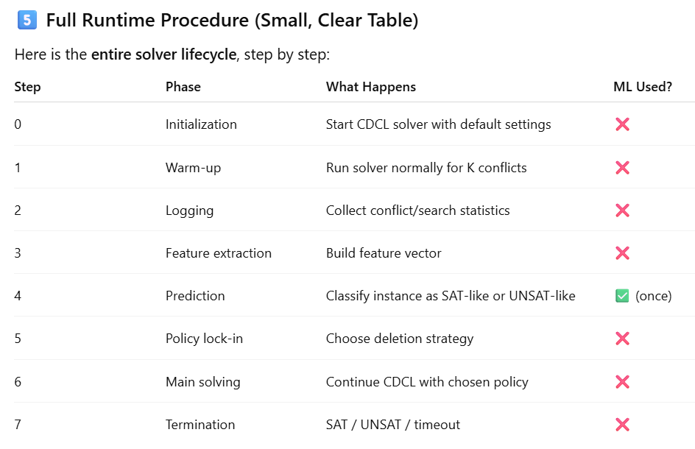

For each SAT instance, the solver performs a short initial exploration phase, extracts search-dynamics features, uses a learned classifier to select a clause deletion strategy, and then completes the search using that strategy deterministically.

• “Adaptive Clause Deletion via Early SAT/UNSAT Prediction in CDCL Solvers”
• “Exploiting SAT–UNSAT Asymmetry for Clause Management in Modern SAT Solvers”
• “Divergent Clause Deletion Strategies Based on Early Search Dynamics”
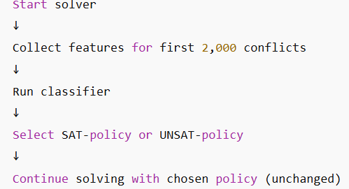

it has never been shown that this distinction can be detected early enough and reliably enough to guide a solver decision

Can early CDCL dynamics reliably predict long-term solver behavior?

Modern CDCL solvers use a single clause deletion strategy for all instances, despite strong empirical evidence that SAT and UNSAT instances benefit from fundamentally different memory management behaviors.

SAT: Once you’re near a solution, many clauses become irrelevant. Forgetting helps exploration.
UNSAT: Every learned clause is a piece of the proof. Deleting clauses weakens future reasoning.

BASELINE METHODOLOGY:

This part done on C++
For each instance, I will run the solver with both aggressive and conservative deletion policy u I will record the solve time, conflicts, result (SAT/UNSAT) etc.

I will add AGG and CONS label to each instance based on performance, hence for example one option is if the aggressive policy took less time to solve than the Conservative approach then it will be labelled as AGG. Issa this is a very simple rule to follow but I am at least giving an example here, I may label depending on the number of conflicts until SAT/UNSAT for example. Further research will be done during the actual methodology section part of this.

For each instance, I will run the solver normally without any policy and stop after the first 2000 conflicts. I will record the features bhal conflicts, restarts, average LBD etc. IF I understand correctly these should be available within the package I just need to log them, these features will be X and the target variable Y will be the lables

Switching to Python, l-istess as per past papers I will be running the model offline and just following standard practice.
I will grab the model from C++
Run on python and evaluate the model and then integrate into the solver once I have my best performing model.
So the solver will run normally, after 2k conflicts It computes features and the ML predicts AGG or CONS, the solver locks a policy and solving continues where HOPEFULLY I will reach better results.

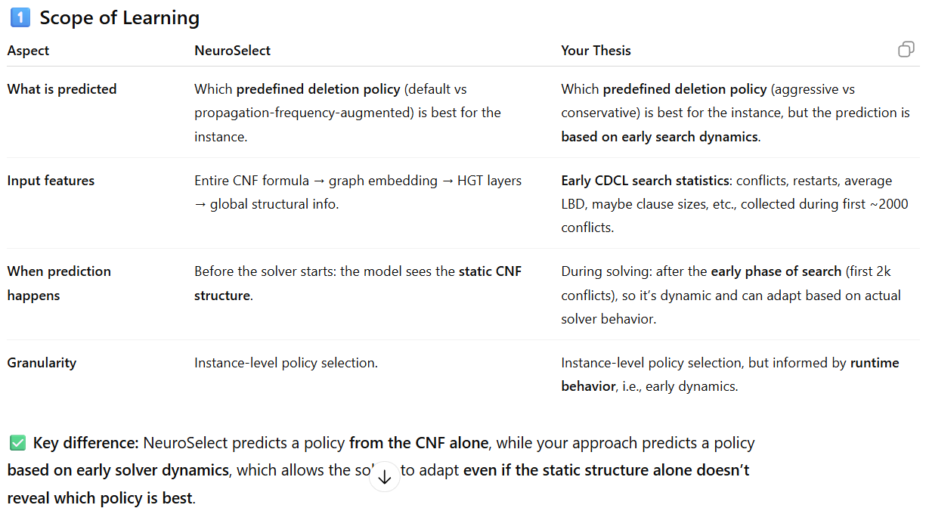
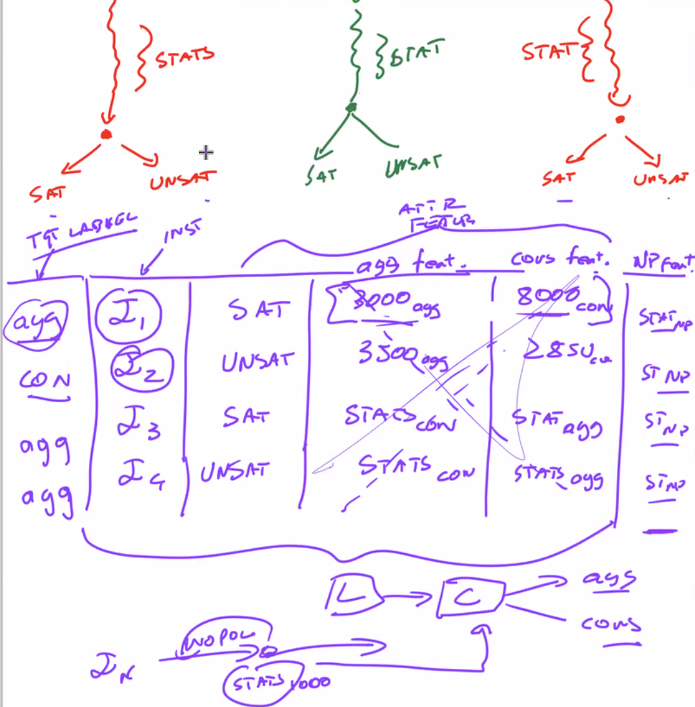

Din zgur qat ma saret ?
Is it really heuristic ?

